Software Re-Engineering – Domain Model

Selected Application:

Library Management System - A Smart, Digitalized Platform for Library Operations

Group Members:
Ammar Hyder 22K-4816
Ausaja Hussain 22K-5186
Muhammad Abdullah 22K-5156

Date: 23/03/26

Introduction
The Library Management System is a console-based application designed to automate and manage the day-to-day operations of a library, including book management, user handling, borrowing processes, and administrative tasks.
This project aims to provide an efficient and structured way to handle library activities such as searching for books, issuing and returning books, managing users (borrowers and staff), and maintaining records of loans and reservations. The system ensures proper separation of concerns by decoupling entities and minimizing logic within the user interface.
This document highlights the core components of the system, specifically the entities involved and the relationships between them, providing a clear understanding of the system’s database structure and design.

Domain Model

Entities & Attributes
- Person – Represents a generic user in the system containing basic personal information such as name, address, and phone number.
- Staff – Represents employees of the library, including librarians and clerks.
- Clerk – Represents a staff member responsible for handling book issuing, returning, and borrower management.
- Librarian – Represents a staff member responsible for managing the library inventory and overseeing operations.
- Borrower – Represents a library member who can borrow books and place requests.
- Book – Represents a book in the library, including details such as title, author, and subject.
- Borrowed_Book – Represents the current borrowing status of a book by a borrower.
- Loan – Represents a transaction where a book is issued to a borrower, including issue and return details.
- On_Hold_Book – Represents a reservation request made by a borrower for a book that is currently unavailable.

Relationships
- A Person can be either a Staff member or a Borrower.
- A Staff member can be either a Clerk or a Librarian.
- A Borrower can borrow many Books through Loan records, or place many On_Hold_Book requests for unavailable books.
- A Book can be borrowed by one Borrower at a time, can appear in multiple Loan records over time, or can be requested by multiple borrowers through On_Hold_Book.
- A Loan is associated with one Borrower & one Book, is issued by a Staff member and may be received/processed by another Staff member upon return.
- A Borrowed_Book links a Borrower with a currently borrowed Book, representing active borrowing.
- An On_Hold_Book links a Borrower with a Book they wish to reserve.
- A Staff member can issue and receive multiple Loan transactions.

Domain Model Diagram
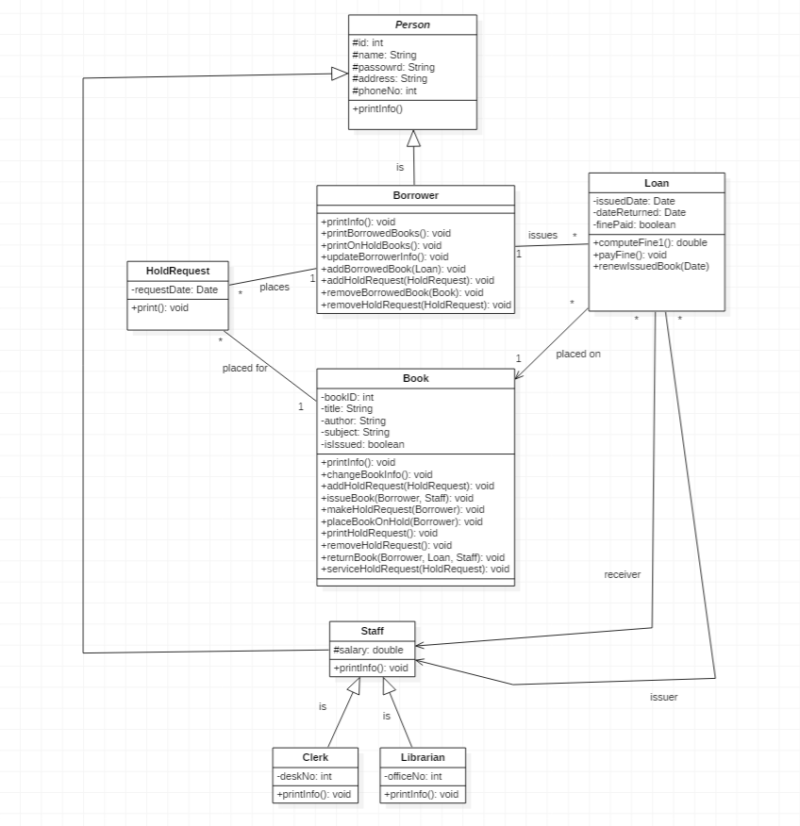

Use Case Model Diagram


